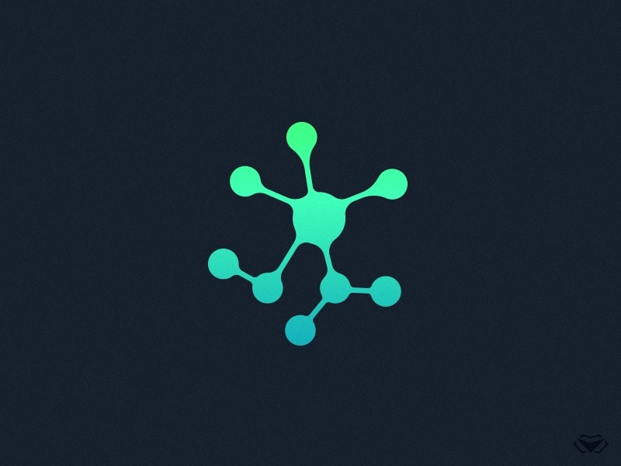

**TEAM 9 MEETING**

**MINUTES**

**Week 9 Group Meeting**

**Meeting Details**

|  |  |
| --- | --- |
| **Team Name:** | Team 9 |
| **Meeting Date:** | 20th October |
| **Time:** | 11:00-12:00 pm |
| **Venue:** | Ezone Video Conferencing Room |
| **Attendees:** | Hadi, Dhruv, Isaac, Matthew, Josh, Dennis |
| **Absent Members:** | Rodney |
| **Minutes Taker:** | Dennis |

**Agenda Details**

|  |  |
| --- | --- |
| Tasks | Sub-tasks |
| Discussions/Clarifications | * Demonstrates the results of the project * Revisit the project requirements from the previous sprints |
| Next Meeting |  |

**Meeting Commences (11:00am)**

Hadi mentions that he will be marking us for today

Hadi asks if we achieved at least 60% of the project

The team feels we have achieved most of our goals

The team mentions how the team submitted the project as a github repo so Michael could fork it

The team demonstrates the simulator to Hadi

Hadi goes through the objectives we established in sprint 1

The team achieves the first objective of being able to run on 60 fps

The team drops the multithreading objectives after agreement with client

The team achieves the objective of being able to add 10 particles

Hadi questions about how the particles would behave with each other

The team demonstrates it by just spawning 2 particles of different and same charges on the box

The team also achieves the isolated environment requirements as the particles doesn’t leave the box

The team achieves the scale test, as we are able to increase/decrease the speed and box sizes

The team mentions a shortcoming that we did not achieve the morse potential, but managed to lay out the foundation that would allow future developers to add new fields and potentials

Hadi goes through the 100$ tests

The team demonstrates the small particle database we have which has actual properties of the first 7 elements of the periodic table

The team also demonstrates the 3d environment and the mouse movement functions

Matthew mentions that all the materials in the 3d environment made based on a lab in Bayliss building are available for future developers

The team demonstrates that the code will always keep the particles inside the box, which allows the client to develop the multiple boxes with ease

The team also shows the documentation, which includes the user manual, which includes the user guide and the developer guide

The team shows our testing document made on google sheets

**Meeting Concludes 12:00**